How to submit an abstract

Abstracts must be one page, A4 format (210 mm x 297 mm), with a top margin of 35 mm, a bottom margin of 30 mm, and right and left margins of 25 mm. Use single-spacing, with Times New Roman or Times fonts for the text.

Abstracts should include your photograph, title, authors, affiliations, addresses of the institutions, e-mail address of the presenting author, and abstract text.
Please refer to the example on the 2nd page.

- Title should be typed in 14-point bold.
- Leave one blank line after the title.
- List all authors (first, middle initial, and last names; 12-point) consecutively, followed, in italics on the next lines, by their affiliations, addresses, and the presenting author’s e-mail address (10.5 point) . Affiliations should be indicated with superscripted numerals, and they should be centered.
- Leave one blank line after the author and affiliation block.
- Type the main text in 12-point plain font. The text should be fully justified (flush right and flush left).

The abstract must be submitted as a 1-page PDF file without security restrictions. All fonts should be embedded in the file. Please name the file "abstract_xxxx (your LAST & first name).pdf," e.g., “abstract_TAHARA tahei.pdf”. The file size should not exceed 500 KB.

Please send the abstract (pdf file) to asc2023@ml.riken.jp along with your registration and submission forms (docx file) by attaching them to the e-mail. We will reply upon receiving your abstract and submission forms.
Soon after the program meeting, which will be held in June-July 2023, we will inform you of whether you have an oral presentation or a poster presentation.
Structural change during ultrafast photoisomerization of cis-stilbene monitored through nuclear wavepacket motion
photo
Taro Riken¹, Bfirst B. Blast^{1,2}, Cfirst Clast²
¹Molecular Spectroscopy Laboratory, RIKEN,
Address: 2-1 Hirosawa, Wako, Saitama 351-0198, Japan
²Department of Chemistry, Graduate School of Science, Osaka University
Address: 1-1 Machikaneyama, Toyonaka, Osaka, 560-0043, Japan
e-mail: taroriken@riken.jp

Stilbene is a prototypical molecule showing photoisomerization (Fig. 1). We recently carried out pump-probe measurements of cis-stilbene with 40-fs time-resolution and observed wavepacket motion (~220 cm⁻¹) in the S₁ state [1]. The dephasing time of the motion was much shorter than the isomerization time, implying that the ~220 cm⁻¹ motion is not directly correlated with the reaction coordinate.
To know more about the reactive potential energy surface (PES) of cis-stilbene, we carried out TR-ISRS experiments [2]. In this experiment, the S₁ state is generated by the UV pump pulse, and the wavepacket motion is induced in the S₁ state by the impulsive Raman process at a certain delay time (ΔT). The resultant wavepacket motion is observed by the third pulse as the oscillation of the transient absorption intensity. We observed the ~220 cm⁻¹ motion also in this experiment. Interestingly, Fourier analysis showed that the frequency of the wavepacket motion significantly changes with the delay time: 239 cm⁻¹ (ΔT =0.3 ps) → 224 cm⁻¹ (1.2 ps) → 215 cm⁻¹ (2 ps). The frequency of the wavepacket motion is determined by the curvature of the S₁ PES along the corresponding coordinate. Therefore, the temporal frequency shift indicates that the relevant curvature of the S₁ PES changes with time. We considered that it reflects a structural change occurring along another coordinate that is anharmonically coupled with the ~220 cm⁻¹ mode.
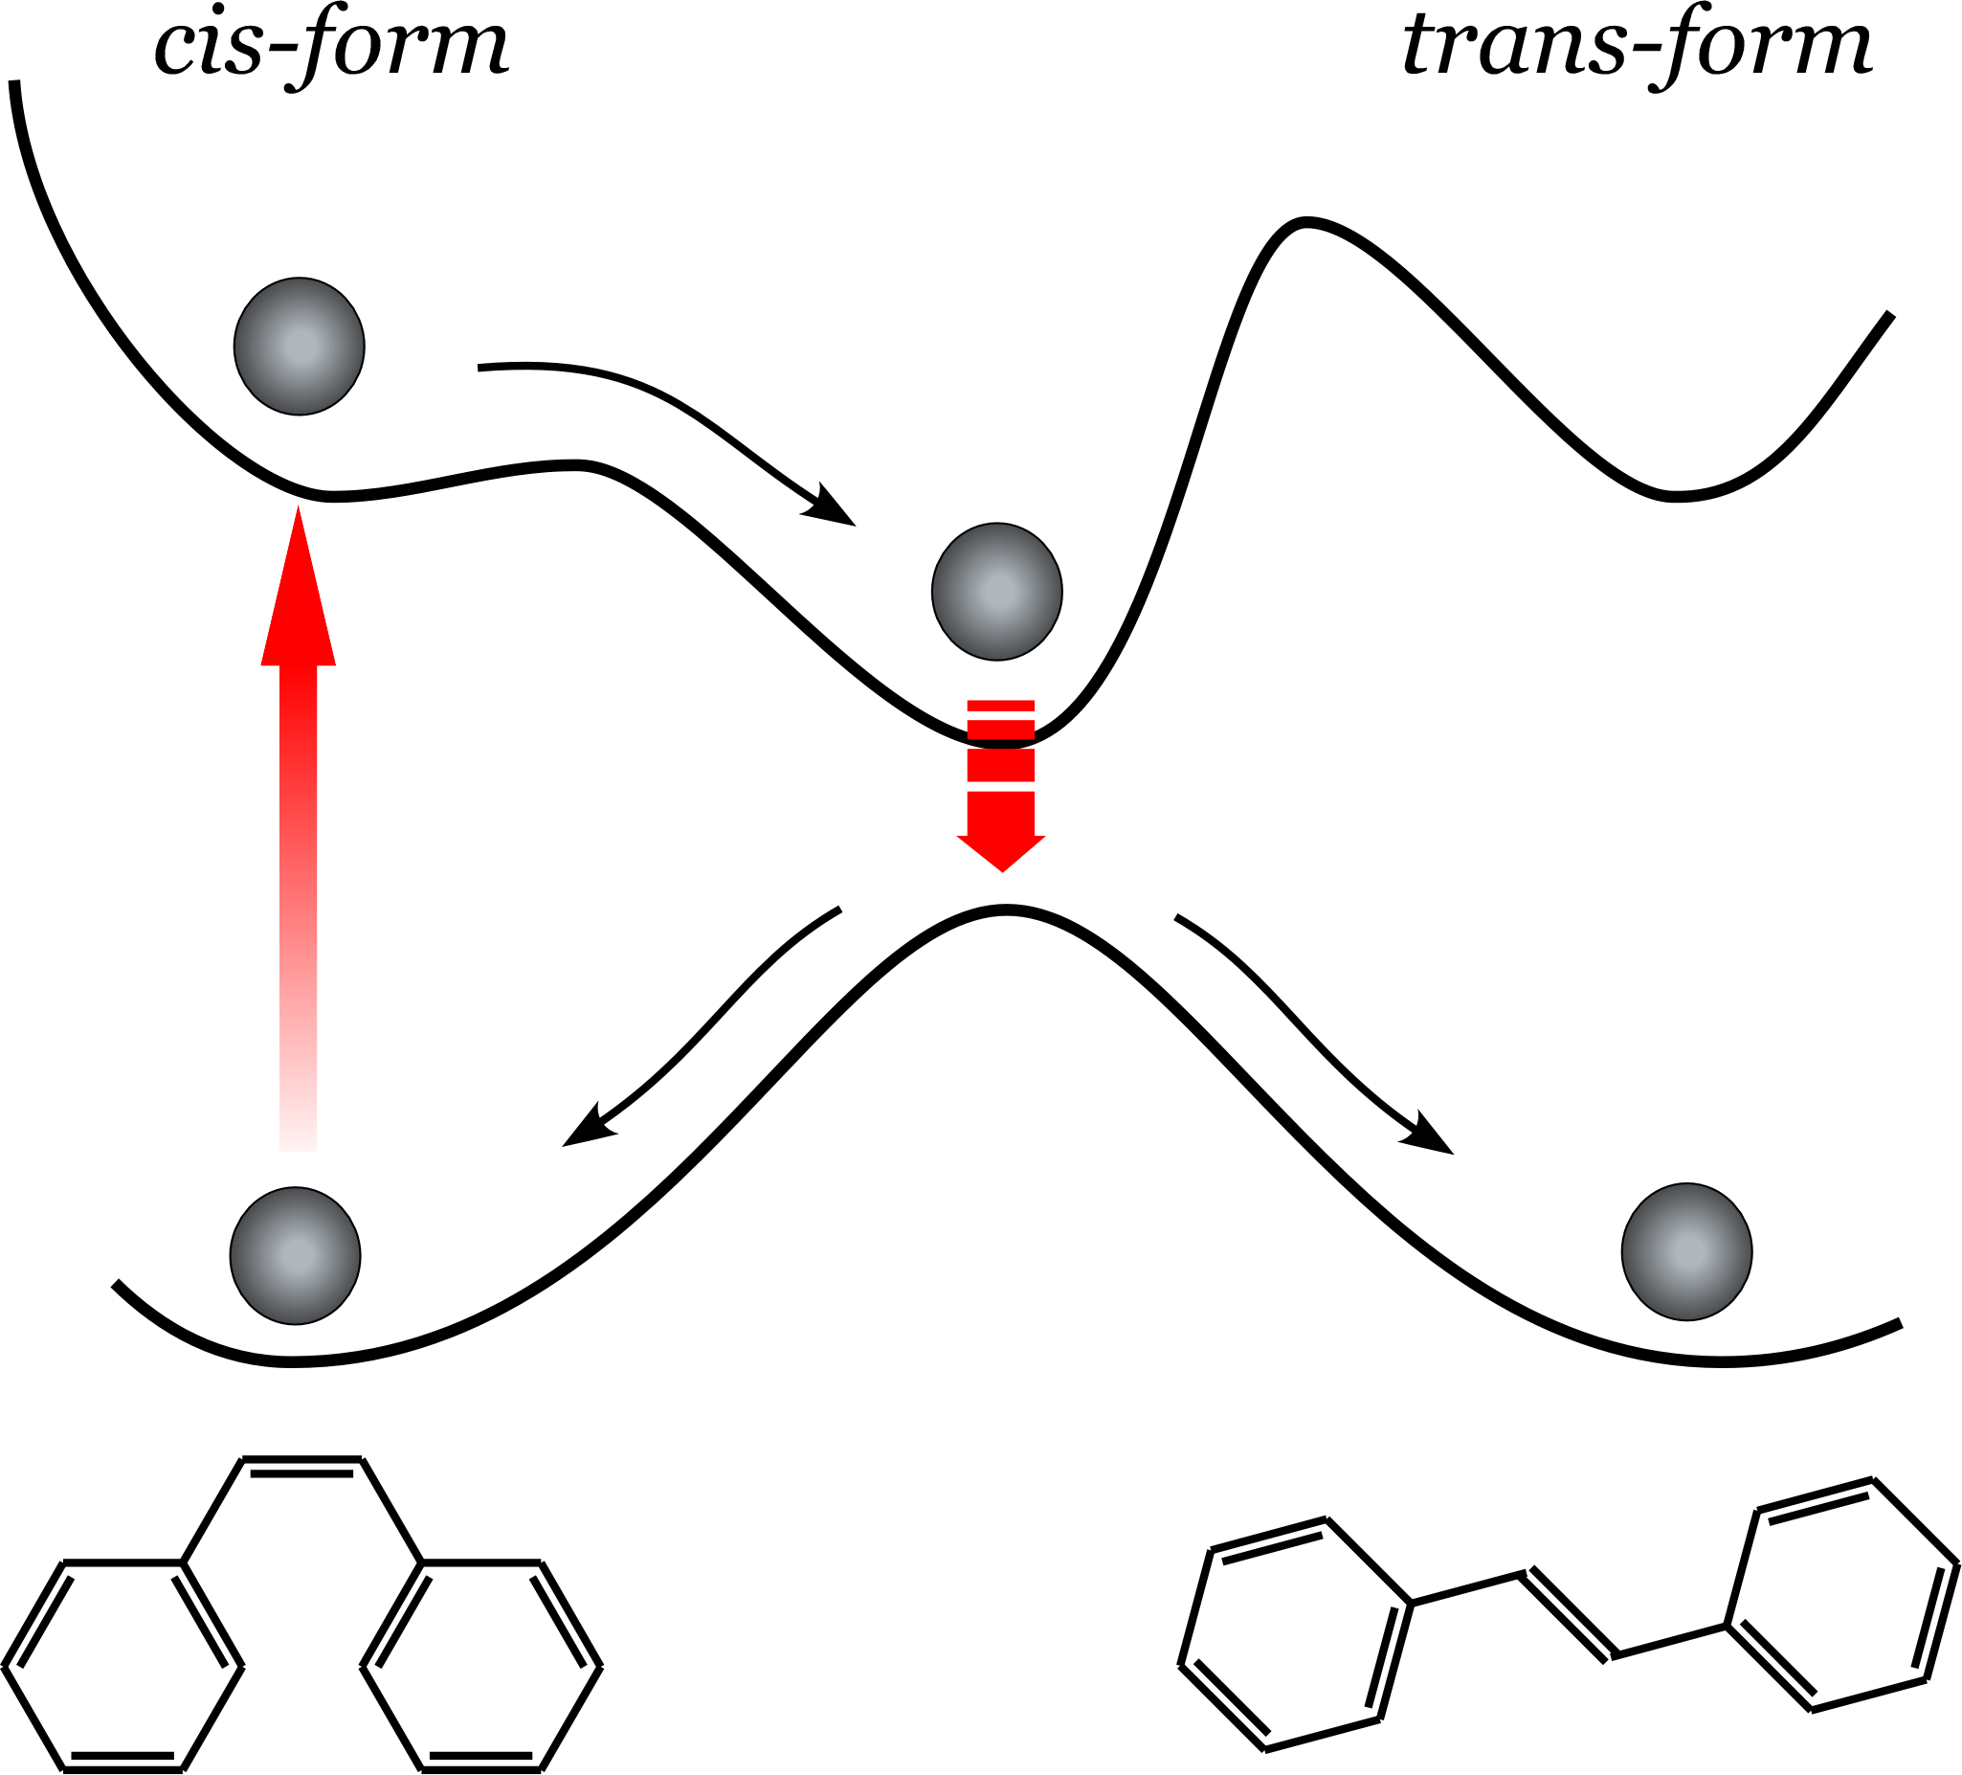
Fig. 1 Photoisomerization of cis-stilbene.

References:
[1] K. Wako, S. Niiza, and T. Riken, Chem. Phys. Lett. 398 (2004) 400.
[2] S. Niiza and T. Riken, Science 322 (2008) 1073

